INTERNATIONAL TRAINING PROGRAMME
Annual Programme 2022: Senior Fellow Role
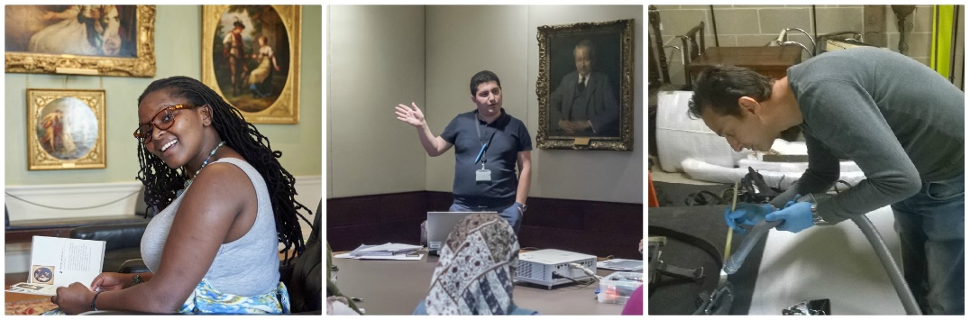
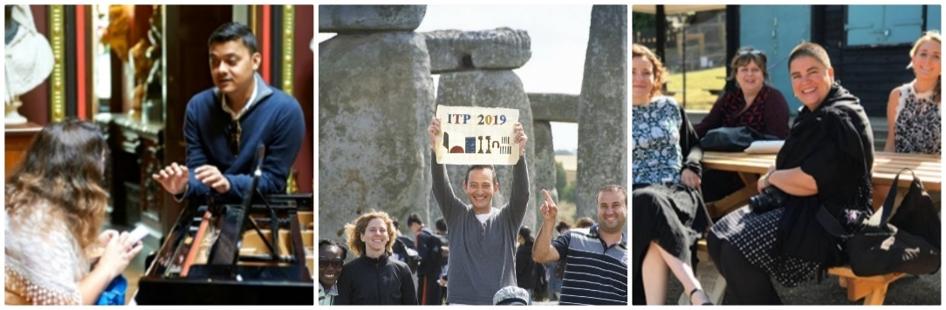

We are pleased to announce applications for the 2022 Senior Fellow Role are now open!

The aim of the placement is for a former ITP Fellow to bring their invaluable experience of the Annual Programme, of London and our UK partner museums to this year’s participants.

22 August – 2 September 2022 e-Learning
3 September to 30 October onsite

We will offer you:

- the chance to assist with developing ideas and strategies for our annual programme (onsite and online e-Learning) and legacy projects.

- experience of organising and delivering training programmes including: developing the flexibility needed to adapt to fellows’ needs and requests; working to immoveable deadlines; working with departments, contributors and partners.

- the chance to further expand your professional network by communicating with colleagues from around the world.

- time in the departments of your choice at the British Museum and a visit to at least one UK partner museum, to re-connect with colleagues and develop new relationships.

- a personalised programme consisting of meetings with the ITP team to understand how the programme is funded, the course is developed and the logistics arranged, and the programme delivered evaluated and finally reported back to stakeholders. Subjects will include the importance of partnerships and social media.

- the necessary skills to cascade your knowledge and experience at your own institution.

As part of the role we will ask you to:

e-Learning:

- contribute to the planning of the annual programme e-Learning.

- prepare and deliver a presentation, with the ITP team, to 2022 fellows about your experiences of the ITP and its role in your career and your institution’s development.

- Offer support to the 2022 fellows during their e-Learning.

- collate and share e-Learning activities.

Onsite at the British Museum:

- prepare documents and contribute to the planning of the annual programme before you arrive in the UK.

- contribute to the delivery of ITP workshops during the annual programme.
Themes include introduction to the annual programme, networking skills, national programmes & UK partner placement, object in focus and a variety of subject specialist sessions

- blog on a weekly basis to create a diary of your role, experiences and achievements and be part of the increasing on-line presence of the ITP.

- manage the ITP ‘social media takeover’ day.

- assist the ITP team with administrative, logistical and practical tasks throughout the programme, including weekend and evening events and supporting fellows whilst staying at London based accommodation alongside them. The workload can be uneven, resulting in some busy and long days mixed with quieter days with more normal working hours.

- reaffirm what is expected of fellows throughout the programme and assist with their pastoral care. To act as a bridge between the ITP team and fellows.

- help evaluate the programme both from a personal perspective and to feedback on comments from programme attendees and facilitators.

- write a 700 word article for the ITP annual report about your experience as a senior fellow.

- guest edit and help to develop the theme of the 2023 ITP newsletter.
We hope that the successful candidate will join us online from 22 August – 2 September 2022 for the remote, e-Learning component of the Annual Programme and from 3 September to 30 October 2022 for the onsite Annual Programme at the British Museum.

We will cover the cost of flights, your UK travel, accommodation, subsistence and any visa related expenses. We will make all necessary arrangements for you.

2022 Annual Programme fellows will arrive on 17 September – 16 October 2022 and the Senior fellow will stay on for a further 2 weeks to assist with the ITP evaluation and write a report.

Before applying:

- Ensure that you are available for the dates above.

- Ensure that you have the permission of your institution and immediate line-management.

- Ensure that you are able to obtain a visa for this period.

- Ensure that your passport is valid until at least 30 April 2023 (6 months after the day of your departure from the UK).

To apply:

Please answer the following questions. Write up to 200 words to answer each question.

What is your understanding of the Senior Fellow role? What does the role mean to you?

What can you bring to the role? Please give details of any training courses or events you have organised before.

Have you been involved in any ITP legacy projects or ITP related projects before? If yes, please make a list below and explain what you took from each experience.

What digital experience do you have? For example, blogging, Facebook, twitter

What experience do you have of e-Learning? (courses/online sessions/lectures etc.)

How will you use what you learn on the programme upon your return home, and how will this benefit you and your institution?

When the 2022 ITP fellows return home you will spend two weeks working with the ITP team to write reports, evaluate the annual programme, meet with colleagues and visit institutions relevant to you. Think about your professional interests and write down:
- your areas of interest
- the people you would like to meet while in London
- departments you would like to visit in the BM
- institutions you would like to visit during your time in the UK

Please also state which UK partner you would like to visit and why. Please select from the list below.

Glasgow Museums, Manchester Art Gallery, Manchester Museum & The Whitworth, National Museums Northern Ireland, Norfolk Museums Service, Nottingham University Museum, The Collection: Art and Archaeology in Lincolnshire, Tyne & Wear Archives & Museums

Submit your answers to the questions above AND YOUR CV by Friday 29 April 2022 to itp@britishmuseum.org

For more information, please contact Anna Cottle at acottle@britishmuseum.org

