International Training Programme
Conference support grant 2023
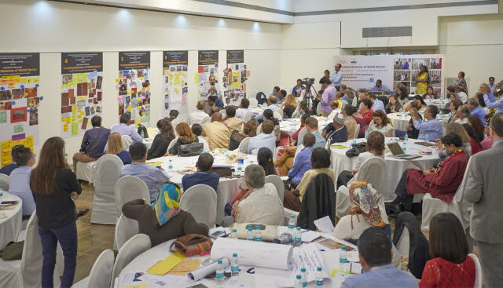
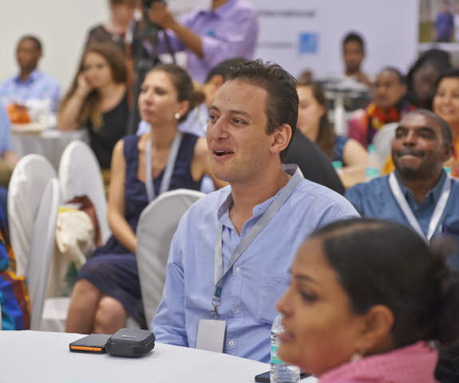
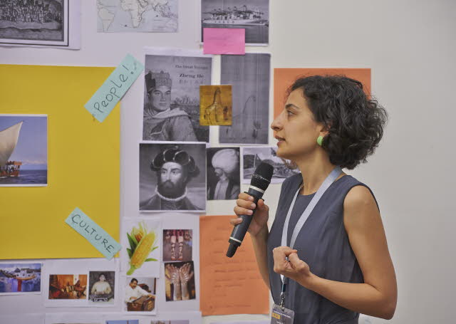

Application Form

Please complete this form giving us as much detail as you can, whilst following the word count guidelines, and return to itp@britishmuseum.org.

If you have any questions or queries, please do not hesitate to contact Claire Messenger (cmessenger@britishmuseum.org) who will be happy to give any help and advice.

Conference support grant 2023

Application Form

Personal Details
Title:- | Dr/Mr/Mrs/Miss/Ms
Forenames:-
Surname (Family name):-
Gender:- | Male/ Female
Nationality:-
Present home address:-
Job title:-
Institution:-
Current work address:-
Work telephone number:-
Home telephone number:-
Mobile telephone number:-
E-mail address:-

ITP History
Which year did you attend the ITP Annual/Summer Programme?
Have you applied for an ITP legacy project before?
If yes, which?
Was the application successful?
Examples:
Conferences (Cairo 2010, Mumbai 2015, Uppsala 2016, Leicester 2016, Glasgow/Bristol 2016, Yerevan 2016, Manchester 2017, Belfast 2018, Brighton 2019)
ITP+ courses (London, Aswan, Mumbai)
Senior Fellow
Collaborative Award
Dresden Fellowship

Conference Details
Title of conference:
Conference institution:
Location of conference (building, city and country):
Start date and end date of conference:
In what capacity are you attending the conference?
- Delegate - listening to talks and asking questions when given the opportunity
- Participant - listening to talks and taking part in workshops / panel discussions
- Speaker – you have been asked to present a paper or lead a workshop.
If you are a speaker – what is the subject of your paper?

Funding Details
We will provide up to £1000.00 for you to attend the conference.

All costs which will be incurred | Approximate cost with link to support estimate  (e.g. Bedford Hotel: /www.imperialhotels.co.uk/)
Grant transfer fees
- If successful, the grant will be transferred in GBP (£)

- Please contact you bank to find out if you will be charged any fees to receive this and state how much this will be here.
Accommodation
- If collecting visa from another city

- At airport, if flight is early

- At conference

Travel
- For visa appointments / to collect visa

- To and from conference

- Travel insurance

Conference fees

Society (ies) membership fees
(may not be relevant)

Subsistence
(transport at conference related to conference, food & drink – does not include alcohol)
Please list any costs unique to your conference attendance
Total sum:
Please write how you will intend to source the conference costs, not covered by the ITP (with as much detail as possible of other funders):

Present job description:
Please tell us about your current responsibilities and day-to-day work. (100 – 200 words)

Please write a short statement about the conference; what it means to you to attend and why it will be helpful to you. If successful, this text will be used in a grant announcement blog on the ITP website. (50 words)

As an ITP Fellow how has your experience of the annual programme helped you shape your professional work and career? Please provide three examples. (100 – 200 words)

How will you use the knowledge, skills and experience gained during this conference to help develop your own museum/institution? (100 – 200 words)

How does your attendance at the conference build on your ITP annual programme experience? Please provide three examples. (100 – 200 words)

How will you promote the ITP at the conference and share your new knowledge with the network? (100 – 200 words)

Please provide 3 examples which demonstrate your:
- organisational skills
- communication skills
- ability to work to tight immoveable deadlines
(Maximum 250 words)

Please provide an example of a time when you applied for funding and what was expected from you. If you have not applied for funding before, write down what you think a funder will expect from you. (100 – 200 words)

Is there any further information that you would like to include to support your application? (100 – 200 words)

Please confirm that your employer (institution and manager) are happy for you to attend the conference:-

Yes _____

Due to the ongoing COVID-19 global pandemic, the grant recipient and the ITP team will need to ensure that any local or international travel is signed off by the appropriate health and safety and management bodies, in line with current government guidelines and changing travel and workplace restrictions.

Please consider if you will need to obtain a visa for your travel to the conference.
Please confirm that you have checked to ensure your passport will be valid and you will be able to meet the criteria for a visa if required:-

Yes _____

To the best of my knowledge the answers given to the questions contained in this personal details form are true and accurate. Any falsification may be considered sufficient cause for rejection from the application process.

Signature:
Name (Printed):
Date:

Please return to: itp@britishmuseum.org

