International Training Programme
Research support grant 2023

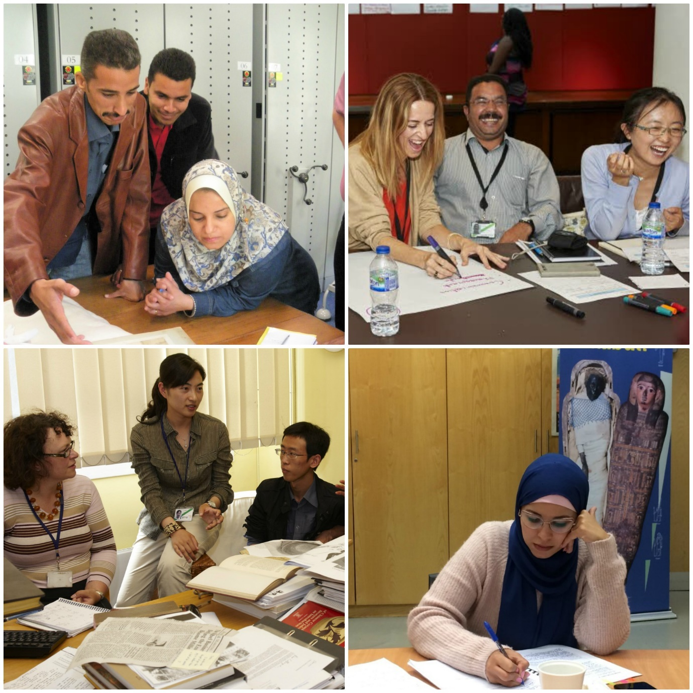

Application Form

Please complete this form giving us as much detail as you can, whilst following the word count guidelines, and return to itp@britishmuseum.org.

If you have any questions or queries, please do not hesitate to contact Claire Messenger (cmessenger@britishmuseum.org) who will be happy to give any help and advice.

Research Support Grant 2023

Application Form

Personal Details
Title:- | Dr/Mr/Mrs/Miss/Ms
Forenames:-
Surname (Family name):-
Gender:- | Male/ Female
Nationality:-
Present home address:-
Job title:-
Institution:-
Current work address:-
Work telephone number:-
Home telephone number:-
Mobile telephone number:-
E-mail address:-

ITP History
Which year did you attend the ITP Annual/Summer Programme?
Have you applied for an ITP legacy project before?
If yes, which?
Was the application successful?
Examples:
Conferences (Cairo 2010, Mumbai 2015, Uppsala 2016, Leicester 2016, Glasgow/Bristol 2016, Yerevan 2016, Manchester 2017, Belfast 2018, Brighton 2019)
ITP+ courses (London, Aswan, Mumbai)
Senior Fellow
Collaborative Award
Dresden Fellowship

Research Proposal Details
Title of research:
Research aims and objectives: What are you researching? What do you hope to achieve or find out through this research project? Briefly describe how you intend to carry out the research and why:
Location of research (where will you be based? Are there any research related trips involved? If so, where?) City, Country.
Start date and end date of research period:
If successful, the grant awardee is asked to create a short film to share with the network during or after the research – this is flexible and can be self-filmed/via Zoom/on a phone or camera/interview format/in-conversation – and this can be discussed at a later date. Are you able to provide this?

Funding Details
We will provide up to £1000.00 for you to carry out the research proposed.

All costs which will be incurred | Approximate cost with link to support estimate  (e.g. Bedford Hotel: /www.imperialhotels.co.uk/)
Grant transfer fees
- If successful, the grant will be transferred in GBP (£)

- Please contact you bank to find out if you will be charged any fees to receive this and state how much this will be here.
Accommodation (if travel is required within research proposal)
- If collecting visa from another city

- At airport, if flight is early

- During research related travel

Travel (if travel is required within research proposal)
- For visa appointments / to collect visa

- To and from location

- Travel insurance

Society (ies) membership fees
(may not be relevant)

Subsistence
(transport related to research, food & drink – does not include alcohol)
Please list any costs unique to your research proposal
Total sum:
Please write how you will intend to source research costs, not covered by the ITP (with as much detail as possible of other funders):

Present job description:
Please tell us about your current responsibilities and day-to-day work. (100 – 200 words)

Please write a short statement about this research; why it is important to you and how it will help you. If successful, this text will be used in a grant announcement blog on the ITP website. (50 words)

As an ITP Fellow how has your experience of the annual programme helped you shape your professional work and career? Please provide three examples. (100 – 200 words)

How will you use the knowledge, skills and experience gained during this research period to help develop your own museum/institution? (100 – 200 words)

How does this research build on your ITP annual programme experience? Please provide three examples. (100 – 200 words)

How will you promote and/or reference the ITP during the research period and share your new knowledge with the network? (100 – 200 words)

Please provide 3 examples which demonstrate your:
- organisational skills
- communication and writing skills
- ability to work to tight immoveable deadlines
(Maximum 250 words)

Please provide an example of a time when you applied for funding and what was expected from you. If you have not applied for funding before, write down what you think a funder will expect from you. (100 – 200 words)

Is there any further information that you would like to include to support your application? (100 – 200 words)

Please confirm that your employer (institution and manager) are happy for you to carry out this research:-

Yes _____

Due to the ongoing COVID-19 global pandemic, the grant recipient and the ITP team will need to ensure that any local or international travel is signed off by the appropriate health and safety and management bodies, in line with current government guidelines and changing travel and workplace restrictions.

Please consider if you will need to obtain a visa for any travel needed as part of your research.
Please confirm that you have checked to ensure your passport will be valid and you will be able to meet the criteria for a visa if required:-

Yes _____

To the best of my knowledge the answers given to the questions contained in this personal details form are true and accurate. Any falsification may be considered sufficient cause for rejection from the application process.

Signature:
Name (Printed):
Date:

Please return to: itp@britishmuseum.org

