INTERNATIONAL TRAINING PROGRAMME
Museums Association conference and ITP networking, Gateshead
4 – 12 November 2023
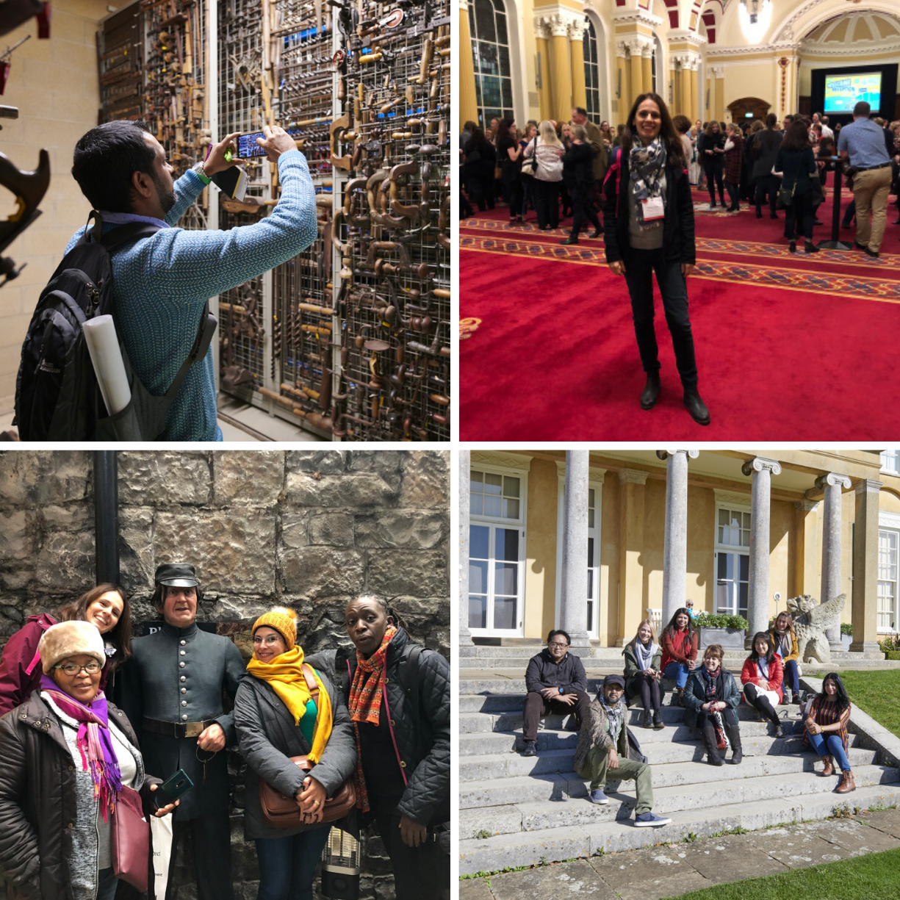

Application Form
Please read the accompanying advert carefully and complete this form giving us as much detail as you can, between 100 - 200 words per question.
Please return this form to itp@britishmuseum.org by midday on Friday 19 May 2023.
If you have any questions or queries, please do not hesitate to contact to contact Claire Messenger (CMessenger@britishmuseum.org) - I will be happy to give any help and advice.

Title:- | Dr/Mr/Mrs/Miss/Ms
Forenames:-
Surname (Family name):-
Nationality:-
Present home address:-
Job title:-
Institution:-
Current work address:-
Work telephone number:-
Home telephone number:-
Mobile telephone number:-
E-mail address:-

ITP History:-
Which year did you attend the ITP Annual Programme?
Have you applied for an ITP legacy project before?
If yes, which?
Was the application successful?
Examples:
Conferences (Cairo 2010, Mumbai 2015, Uppsala 2016, Leicester 2016, Glasgow/Bristol 2016, Yerevan 2016, Manchester 2017, Belfast 2018, Brighton 2019, Edinburgh 2022)
BM Empire Symposium 2018
ITP+ course (May 2017, December 2017)
ITP+ Aswan 2018
ITP+ Mumbai 2019
ITP Futures 2020
Senior Fellow
Collaborative Award
Dresden Fellowship

Present job description:-
Please tell us about your current responsibilities and day-to-day work.
Please include how your work relates to the conference theme of how museums can help their communities flourish by having a positive impact on health and wellbeing, placemaking, economic regeneration and by providing space to reflect on the pressing issues that we face (100 – 200 words).

As an ITP Fellow how has your experience of the annual programme helped you shape your professional work and career? Please provide three examples. One example should relate to the conference theme of ‘The Power of Museums’ (100 – 200 words total)

This event will be an ideal opportunity to engage with fellows from the ITP global network and the wider museum sector. How do you plan to make the most of this opportunity for networking? What benefits can you see for you and your institution? Please give specific examples. (100 – 200 words)

What does the conference theme of ‘The Power of Museums’ mean to you? Why does this conference theme interest you? (100 – 200 words)

Describe a project, programme, activity or partnership in your museum (or the museum sector in your country) that is working to help your communities flourish by having a positive impact on health and wellbeing, placemaking, economic regeneration and by providing space to reflect on the pressing issues that they face? (100 – 200 words)

Please research Gateshead’s heritage, museums and galleries. You may want to begin your research with these two websites:
https://newcastlegateshead.com/explore/gateshead
https://visitnewcastle.com/
Which museums, galleries and heritage sites would you be interested to visit?
What do you feel you can gain professionally from visiting the city of Gateshead? (100 – 200 words)

What specific plans do you have for applying the knowledge, skills and experience gained from this opportunity once you get home? (100 – 200 words – please be specific!)

Is there any further information that you would like to include to support your application?

Please confirm that your employers (institution and manager) are happy for you to attend
this course from 4 – 12 November 2023.

Please tick to confirm either:

Yes ____ No _____

To obtain a visa for travel, your passport must be valid for the duration of your visit.
In this case, until 13 November 2023.
Please tick to confirm either:
a) My passport is valid beyond 13 November 2023 ____
b) I am aware that if I am accepted for the conference, I will need to renew my passport immediately ____

To the best of my knowledge the answers given to the questions contained in this personal details form are true and accurate. Any falsification may be considered sufficient cause for rejection from the application process.

Signature:-
Name (Printed):-
Date:-

Please return to:-
International Training Programme
E-mail: itp@britishmuseum.org

