INTERNATIONAL TRAINING PROGRAMME
Annual Programme 2025: Senior Fellow role

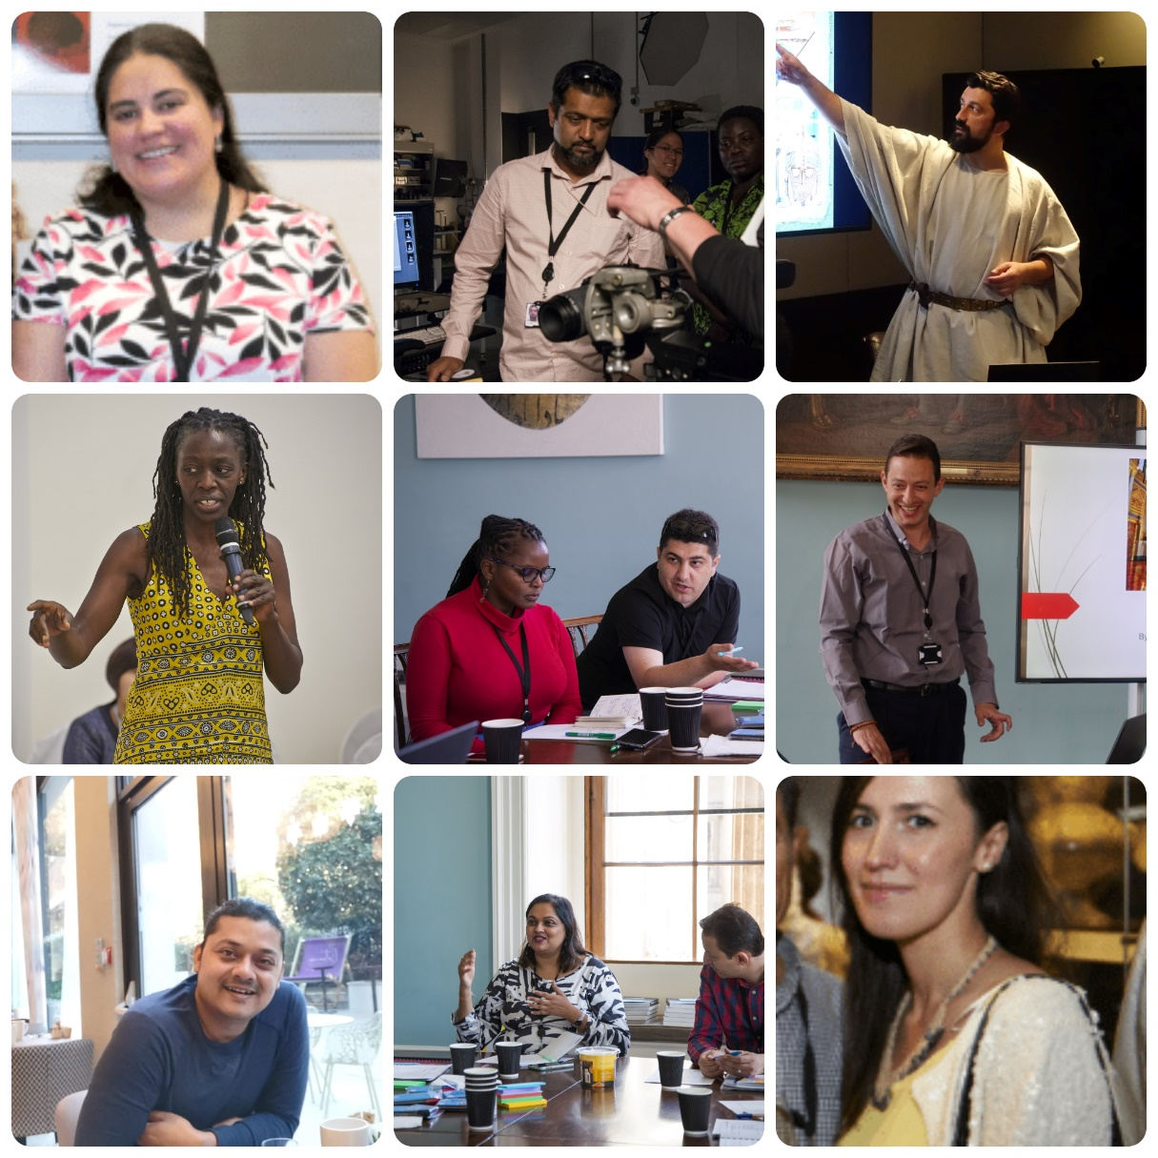

We are pleased to announce applications for 2025 are now open!
‘As a senior fellow, I wanted to reiterate the phenomenal experience I had. It involved engaging in meaningful dialogues with museum friends and colleagues, expanding my knowledge of museum management across the UK, and enhancing my leadership skills. I also wanted to accept the challenge of becoming the support and compass for the new fellows, helping them to navigate through the program while having a fulfilling and enjoyable journey.’
Yanoa Pomalima Carrasco, Museum and Heritage consultant (Peru, ITP Fellow 2022, Senior Fellow 2024)

The role of Senior Fellow is taken on by a former ITP fellow to help facilitate the Annual Programme. Having participated on the Annual Programme previously you will provide fellows of 2025 with knowledge of the course, of London and our UK partner museums.

The role offers the opportunity to gain further training in the delivery and development of skills-sharing programmes, to reconnect with BM and UK partner colleagues and to make new connections across our global network.

To date we have been joined by ten ITP Fellows who have taken on the role of Senior Fellow. Please consider contacting them for help, advise and support in deciding if this role is for you and completing the application form, I am sure they would be very happy to help.

As the twelfth Senior Fellow, you will be an invaluable member of the ITP team, helping with the logistics and development of the annual programme, offering ideas for our legacy and sustainability projects, and providing support to the ITP team and fellows during the programme.
During the ITP Annual Programme you will be asked to develop and deliver a workshop for the 2025 cohort, based around the theme of the Future of Museums. It is up to you how to decide to interpret what the future of museums is, and you can use your own role profile and professional interests. You will be supported by the ITP team and colleagues around the Museum as needed.
As Senior Fellow 2025 you will also take on the role of ‘guest editor’ of the ITP Newsletter 2026 helping develop the theme and content.
You will also be invited to join the new ITP Advisory Group made up of the ITP Senior Fellows who are bringing their skills, knowledge and lived experience of culture and heritage sectors around the world, to help shape the International Training Programme.
For more information and to apply, read through and fill in the application form. If you have any more questions please contact gpeckham@britishmuseum.org.

Please submit your application by Midday on Friday 20 December 2024 by email to itp@britishmuseum.org

