

International Training Programme 2027

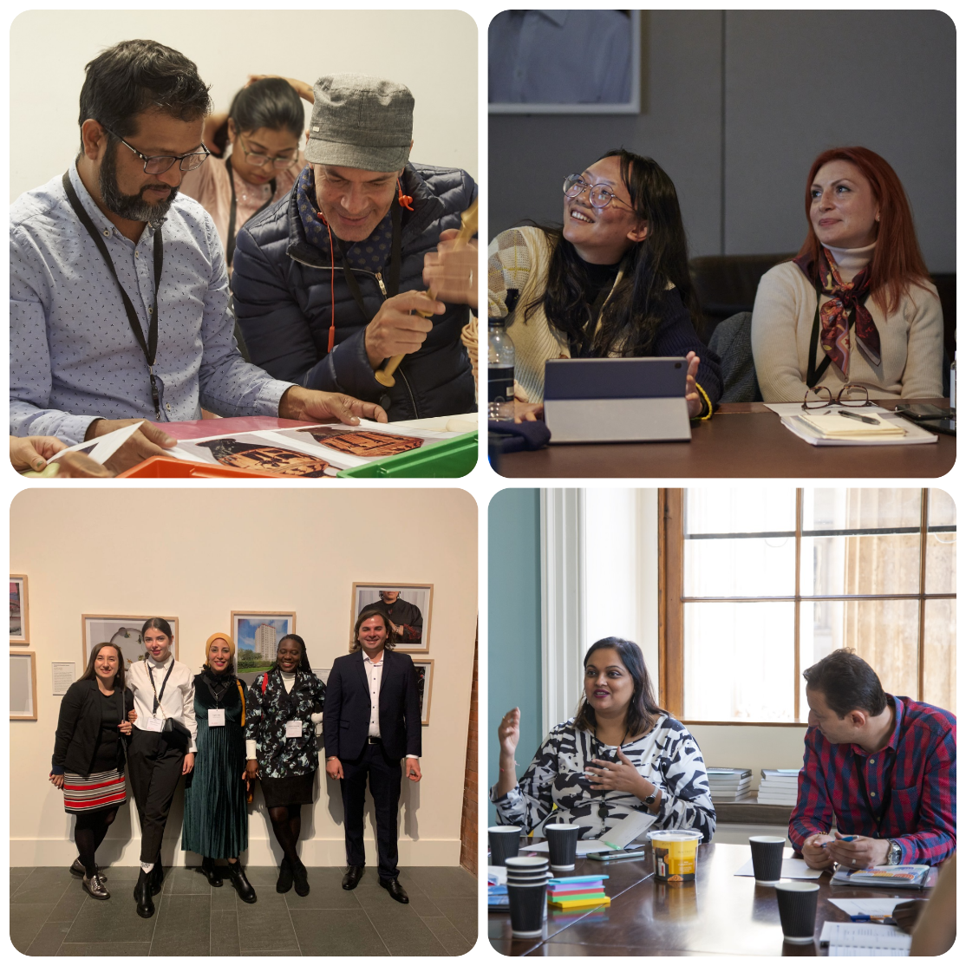

Application Form

The International Training Programme 2027 will take place, over six-weeks, from Saturday 3 July to Sunday 15 August (including travel dates).

Please complete this form giving us as much detail as you can.

To find out more about the British Museum’s International Training Programme, please see the links below:

ITP Website: https://www.britishmuseum.org/our-work/international/international-training-programme
ITP Blog: https://bmitpglobalnetwork.org/
ITP LinkedIn: https://www.linkedin.com/company/international-training-programme
ITP Email Address: itp@britishmuseum.org
ITP Twitter Account: @britmusitp
ITP Instagram: @britmusitp
International Training Programme 2027 Application Form

Before completing this application form, please ensure you have read and understood our application guidelines. If there are any terms and conditions in the guidelines that you cannot adhere to, you MUST note these in your application. Failure to do so could result in your place on the ITP annual programme being withdrawn.

Title:- | Dr/Mr/Mrs/Miss/Ms
Forenames:-

Surname (Family name):-

Nationality:-

Present home address:-
Job title:-

Institution:-

Current work address:-
Work telephone number:-

Home telephone number:-

Mobile telephone number:-

E-mail address:-

Present job description:-
Please write 200 words about your responsibilities and day-to-day work.

Museum interests:-
Why are you interested in attending the International Training Programme?

Please write 200 words on why the British Museum’s International Training Programme, specifically, is the course for you.

You might like to consider the museum areas you would be interested in learning more about during the ITP (for example Exhibitions, Education, Fundraising, Conservation, Marketing, Photography, Security, Collections database, Storage, Libraries & archives, etc.)

You can visit the British Museum website: http://www.britishmuseum.org/ for ideas of the different Departments, what they do, and which ones may be appropriate for your aims during the ITP.

Research interests:-
Please tell us about your research interests and any projects you are currently working on.

Please note that this is not a research programme. If your main interest is research, we suggest you apply for a separate research visit.

Goals:-
What would be your specific goals for your time at the British Museum and UK Partner museum, both professionally and personally?
Please list the three most important things you would you like to gain from the programme?

1.

2.

3.

What are your hopes and goals for your museum/heritage sector over the next 10 years?

Your home institution:-
Does your institution/manager have any specific issues they would like you to address through this training programme? If you are a freelance or independent professional then you should consider the current challenges in culture and heritage in your home country.

How would you use your experience of the ITP to benefit your work and institution? If you are a freelancer or independent, how would you use your ITP experience in your work?

Working internationally:-
One of the key objectives of the International Training Programme is to be a forum for museum professionals from diverse institutions and backgrounds from around the world to exchange ideas and share skills which will help shape the museums of the future. Our goal is to develop
a sustainable global network which provides a platform for continued discussion and collaboration.

What do you feel are the benefits and challenges of working internationally?

Benefits:

Challenges:

The ITP is all about creating a global network – how will you keep connected after the ITP annual programme and what will you bring to the network?

Is there any further information that you would like to include?

References:-
Please provide the names and contact details of two people whom we may contact as referees to comment on your suitability to undertake the training placement at The British Museum. We would like one referee to be from your current employment, university or college. The other referee can be a colleague, friend, doctor or teacher but not a family member.

If you are accepted for a place on the International Training Programme 2027 you will need to confirm, in writing, that your employer (institution and manager) has given permission for you to attend this course.

Please note, the British Museum reserves the right, in exceptional circumstance, to cancel, delay or change the dates of the ITP annual programme, as well as to change any aspect of the ITP’s delivery, including its content, location, or personnel. The ITP will endeavour to give you as much notice of such changes as reasonably possible but be aware that such changes may need to be made at short notice.

How did you hear about the International Training Programme? Mark ‘X’ next to your answer

British Museum Website
ITP website (bmitpglobalnetwork.org)
Social Media
Your own institution/colleague
British Museum staff/connections
Search engine (Google, Yahoo, Bing)
Other (please provide details below):

To the best of my knowledge the answers given to the questions contained in this
personal details form are true and accurate. Any falsification may be considered sufficient cause for rejection from the International Training Programme.

Signature:-
Name (Printed):-
Date:-

As part of your application, please also provide a 2-page CV

